Software Requirement Specifications
Online Election Voting for University Teachers



Submitted to
Nimra Rafeeq (F22BINFT1M01033)
Submitted to
Mr. Muzammil Ur Rehman

Department of Information Technology
Faculty of Computing
The Islamia University of Bahawalpur

Meeting Details
Sr No | Details | Date | Supervisor Signature
Summary
This Software Requirement Specification (SRS) document provides a detailed description of an Online Election Voting Website designed specifically for university teachers. The purpose of the system is to digitize the election process for university bodies—such as faculty committees, departmental representatives, and other academic councils—making the voting process efficient, transparent, and secure.
The document summarizes system goals, scope, functional requirements, non-functional requirements, use cases, workflows, and relevant technologies. It ensures that all stakeholders have a clear understanding of system features and behavior before development begins.

Table of Contents
1. Introduction 4
1.1. Purpose 4
1.2. Scope 4
1.3. Product Perspective 4
1.4. User Characteristics 4
1.5. Similar apps and systems/Literature Review 4
1.6. Proposed Technologies 4
2. Requirements 5
2.1. Function Requirements 5
2.1.1. Sign Up 5
2.2. Non-Functional Requirements 5
3. Use Cases and Flow of Processes 6
3.1. Use Case 1 7
4. References 8

- Introduction
Universities frequently conduct elections for different academic and administrative bodies. Traditionally, these elections are paper-based and require physical presence, which results in higher time consumption, administrative overhead, and potential risks of errors or bias.
1. The Online Election Voting Website aims to automate and digitalize elections for teachers in the university. This system ensures secure authentication, transparent vote tallying, candidate information visibility, and fair results generation.
- It will serve faculty members (voters), election administrators, and super administrators.

  - Purpose

Purpose of this project is to:
- Provide a secure and transparent online voting system for university teachers.
- Reduce manual workload and paperwork traditionally required in university elections.
- Prevent fraudulent activities by introducing secure authentication.
- Ensure fast and accurate results processing.
- Enable teachers to cast votes anytime within the allowed duration without needing to be physically present.

  - Scope

The scope of this project includes the development of a web-based platform with:
- User registration & login (Teachers & Admins)
- Candidate management
- Election creation and scheduling
- Secure voting system
- Result generation and display
- Activity logs
Out of Scope:
- Mobile application (future enhancement)
- SMS-based verification
- Biometric authentication

  - Product Perspective

This system will act as an independent module for conducting teacher elections. It can be integrated with an existing university portal in the future. The system handles all election-related operations including registration, authentication, voting, and results.
  - User Characteristics
- • Teachers (Voters): Basic computer knowledge, ability to use web browsers.
- • Admin: Moderate technical skills, responsible for managing elections, candidates, and results.
- • Super Admin: High-level user responsible for approving accounts and monitoring entire system functionality.

Similar apps and systems/Literature Review
Several online voting platforms exist such as:
- Helios Voting System – Open-source, secure but complex UI.
- Election Buddy – Easy to use but paid.
- Opa Vote – Supports many voting types but lacks UI personalization.
Shortcomings of existing systems include:
- Not tailored for universities.
- Limited customization.
- High cost for premium systems.
Our system improves on these by providing:
• University-specific features
• Free usage
• Simple and intuitive interface

  - Proposed Technologies
• Frontend: HTML5, CSS3, JavaScript, Bootstrap/React (optional)
• Backend: PHP / Django / Node.js (depending on development preference)
• Database: MySQL / PostgreSQL
• Version Control Git & GitHub
• Hosting: XAMPP / WAMP / Cloud-based server

- Requirements

The Online Election Website includes several major functionalities:
- Secure user registration and login system.
- Admin dashboard for managing elections and candidates.
- Election scheduling features.
- Voting portal allowing one-time vote submission.
- Automatic result generation.
- Logging of user activity for transparency.
  - Function Requirements

Below are the detailed functional requirements using the standard format

3.1.1Sign Up
Below are the detailed functional requirements using the standard format.

FR001 – Sign Up
Name: FR001
Purpose: To allow teachers and admins to register and become system members.
User(s): Teacher, Admin
Input:
- Full Name
- Email (official university email)
- Password (min 8 characters, includes a number)
- Password (min 8 characters, includes a number)
- • Department
- • Phone Number
- • Profile Picture
- • Approval from Super Admin
- Output:
A registered user who can log in after approval.

FR002 – Login
Purpose: Allow authenticated access to the system.
Users: Teacher, Admin, Super Admin
Input: Email, Password
Output: Redirect to respective dashboard.
FR003 – Create Election
Purpose: Admin creates new election with title, date, duration.
User: Admin
Input: Election Title, Description, Start Date, End Date
Output: Election added to system.
FR004 – Add Candidates
Purpose: Add teacher candidates participating in election.
User: Admin
Input: Name, Department, Profile Image, Candidate Statement
Output: Candidate appears in voting list.
FR005 – Cast Vote
Purpose: Allow teachers to cast their vote securely.
User: Teacher
Input: Candidate Selection
Output: Vote stored in database; user marked as "Voted".

FR006 – View Results
Purpose: Show election results after voting ends.
User: All users (restricted until election ends)
Output: Winner details + vote counts.

2.2 Non-Functional Requirements
Security:
- Data encryption for passwords
- One user can vote only once
- Admin privileges secured
Performance:
- System must handle 200+ concurrent users
Reliability:
- 99% uptime required during elections
Usability:
- Simple UI for teachers with minimal training
Availability:
- System accessible 24/7 during election duration

- Use Cases and Flow of Processes
This project contains only one primary use case, which is the Sign Up Use Case. All system processes revolve around user registration and approval.

  - Use Case 1
ID | Uc001
Name | Sign up
Description | This use case describes how a teacher or admin creates an account on the Online Election Voting System and submits it for approval by the Super Admin.
Requirement(s) | FR001
Actor(s) | Teacher, admin
Precondition | • User must not already have an existing account.  • User must have a valid university email.
Postcondition | User account is created and sent for approval by the Super Admin.
Basic Flow | Basic Flow  - Actor enter credentials  - System validates the inputs  - Following fields are required  - Name  - Email  - Password  - Address  - Phone  - Check the proper inputs for following  - Email  - Password must be 8 character including number  - Phone Number on 11 digits  - On successful validation the system will create new user  Alternative Flow  - Admin Sign In  - Create a new User by entering data  Exceptions  - Invalid Inputs  - System unable to response
Diagrams

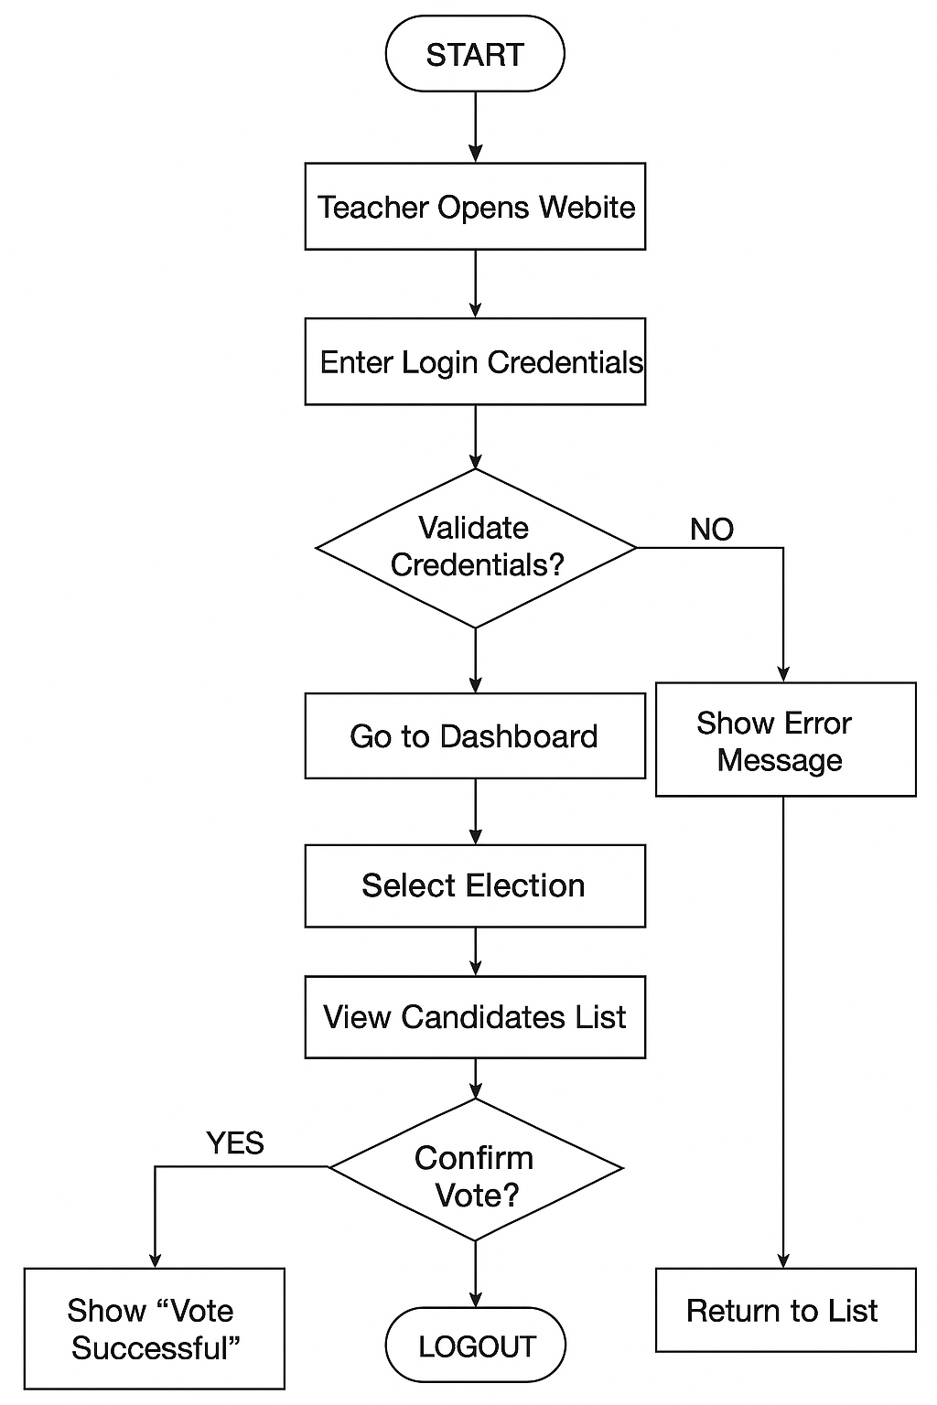
- References

IEEE SRS Standard
IEEE Computer Society, IEEE Std 830-1998: Software Requirements Specification Standard, IEEE, 1998.
👉 (This shows your SRS is based on an international standard — supervisors like this.)

Research Paper on Online Voting
Ankit, A., & Jain, A., “Online Voting System Using Secure Authentication,” International Journal of Computer Applications (IJCA), vol. 144, no. 1, pp. 6–10, 2016.
👉 (A simple, real paper directly related to your project.)

